Effect of crustal contamination/assimilation on potential temperature calculation

During the Archean period, the assimilation of continental crust by basaltic magma is a common occurrence, and it can significantly impact the calculation of potential temperature. Assimilating a substantial amount of continental crust can lead to changes in the concentration of major oxides, thereby influencing the estimation of potential temperature.
To illustrate the effect of crustal contamination, we have utilized the FCA (Decoupled Fractional Crystallization and Assimilation) model (Ersoy and Helvaci 2010). This model considers the fractionation of olivine in the input basalts and the subsequent assimilation of the upper continental crust by the fractionated basalt. The model explores various "r" values, which represent the relative ratio of assimilated material to crystallized material. The initial experimental melt composition used in this study is sourced from Davis and Hirschmann (2013) (Table R3T1). The MgO vs. CaO relationship suggests no clinopyroxene-related fractionation history for the melt composition. In this context, we explore the impact of olivine fractionation and subsequent melt assimilation on the calculation of mantle potential temperature (T_{p}).
Initially, the melt undergoes a 9% fractionation process involving only olivine, excluding assimilation (Table R3T2). Following this, the same melt undergoes olivine fractionation alongside the assimilation of crustal material. The composition of the assimilant is sourced from Rudnick et al. (2003). The change in melt composition with increasing “r” value are shown from Table R3T3 to R3T5. The subsequent change in MgO and CaO values are shown in figure R3S1.

Table R2T1. Starting melt composition.
SiO₂ | TiO₂ | Al₂O₃ | FeO | MnO | MgO | CaO | Na₂O | K₂O | Tp (℃) at Fo= 0.92 and Fe⁺³/Fe_{T}=0.1
44.1 | 2.86 | 13.42 | 9.08 | 0.13 | 15.68 | 9.20 | 2.67 | 1.39 | 1485.97

Table R2T2. Olivine Fractionation only.
Percentage of melt remaining | SiO₂ | TiO₂ | Al₂O₃ | FeO (t) | MnO | MgO | CaO | Na₂O |  | K₂O | Tp (℃) @ Fo= 0.92 and Fe⁺³/Fe_{T}=0.1
100.00% | 44.1 | 2.86 | 13.42 | 9.08 | 0.13 | 15.68 | 9.2 | 2.67 |  | 1.39 | 1485.975439
99.00% | 44.2 | 2.89 | 13.55 | 9.13 | 0.13 | 15.15 | 9.29 | 2.7 |  | 1.4 | 1484.875292
98.00% | 44.31 | 2.92 | 13.69 | 9.17 | 0.13 | 14.63 | 9.38 | 2.72 |  | 1.42 | 1484.235192
97.00% | 44.41 | 2.95 | 13.83 | 9.21 | 0.13 | 14.12 | 9.47 | 2.75 |  | 1.43 | 1484.037978
96.00% | 44.52 | 2.98 | 13.97 | 9.26 | 0.13 | 13.63 | 9.56 | 2.78 |  | 1.45 | 1480.000663
95.00% | 44.62 | 3.01 | 14.12 | 9.3 | 0.13 | 13.14 | 9.66 | 2.81 |  | 1.46 | 1480.646141
94.00% | 44.73 | 3.04 | 14.27 | 9.35 | 0.13 | 12.67 | 9.76 | 2.84 |  | 1.48 | 1481.689659
93.00% | 44.84 | 3.07 | 14.42 | 9.39 | 0.13 | 12.22 | 9.86 | 2.87 |  | 1.49 | 1483.117816
92.00% | 44.95 | 3.1 | 14.57 | 9.44 | 0.14 | 11.77 | 9.96 | 2.9 |  | 1.51 | 1480.659296
91.00% | 45.07 | 3.14 | 14.73 | 9.48 | 0.14 | 11.34 | 10.06 | 2.93 |  | 1.53 | 1482.824866

Table R2T3. Olivine fractionation and assimilation by upper continental crust at r = 0.1.
Percentage of melt remaining at r=0.1 | SiO₂ | TiO₂ | Al₂O₃ | FeO (t) | MnO | MgO | CaO | Na₂O | K₂O | Tp (℃) @ Fo= 0.92 and Fe⁺³/Fe_{T}=0.1
100.00% | 44.1 | 2.86 | 13.42 | 9.08 | 0.13 | 15.68 | 9.2 | 2.67 | 1.39 | 1485.975439
99.00% | 44.23 | 2.89 | 13.56 | 9.13 | 0.13 | 15.13 | 9.28 | 2.7 | 1.41 | 1484.250944
98.00% | 44.36 | 2.91 | 13.69 | 9.16 | 0.13 | 14.6 | 9.37 | 2.73 | 1.42 | 1483.027486
97.00% | 44.49 | 2.94 | 13.84 | 9.2 | 0.13 | 14.08 | 9.45 | 2.75 | 1.44 | 1482.284742
96.00% | 44.62 | 2.97 | 13.98 | 9.24 | 0.13 | 13.57 | 9.54 | 2.78 | 1.45 | 1477.736617
95.00% | 44.75 | 2.99 | 14.13 | 9.28 | 0.13 | 13.08 | 9.62 | 2.81 | 1.47 | 1477.903828
94.00% | 44.89 | 3.02 | 14.28 | 9.32 | 0.13 | 12.6 | 9.71 | 2.84 | 1.49 | 1478.498908
93.00% | 45.02 | 3.05 | 14.43 | 9.35 | 0.13 | 12.13 | 9.8 | 2.87 | 1.5 | 1475.242435
92.00% | 45.16 | 3.08 | 14.58 | 9.39 | 0.14 | 11.68 | 9.9 | 2.9 | 1.52 | 1476.652364
91.00% | 45.3 | 3.11 | 14.74 | 9.43 | 0.14 | 11.24 | 9.99 | 2.93 | 1.54 | 1478.445812

Table R2T4. Olivine fractionation and assimilation by upper continental crust at r = 0.2.
Percentage of melt remaining at r=0.2 | SiO₂ | TiO₂ | Al₂O₃ | FeO (t) | MnO | MgO | CaO | Na₂O | K₂O | Tp (℃) @ Fo= 0.92 and Fe⁺³/Fe_{T}=0.1
100.00% | 44.1 | 2.86 | 13.42 | 9.08 | 0.13 | 15.68 | 9.2 | 2.67 | 1.39 | 1485.975439
99.00% | 44.26 | 2.88 | 13.56 | 9.12 | 0.13 | 15.12 | 9.27 | 2.7 | 1.41 | 1483.472081
98.00% | 44.42 | 2.91 | 13.7 | 9.15 | 0.13 | 14.57 | 9.35 | 2.73 | 1.43 | 1481.523839
97.00% | 44.58 | 2.93 | 13.84 | 9.18 | 0.13 | 14.03 | 9.42 | 2.76 | 1.44 | 1480.106062
96.00% | 44.75 | 2.95 | 13.99 | 9.21 | 0.13 | 13.51 | 9.5 | 2.78 | 1.46 | 1474.928424
95.00% | 44.91 | 2.98 | 14.14 | 9.25 | 0.13 | 13 | 9.58 | 2.81 | 1.48 | 1474.508749
94.00% | 45.08 | 3 | 14.29 | 9.28 | 0.13 | 12.51 | 9.66 | 2.85 | 1.5 | 1474.555977
93.00% | 45.25 | 3.03 | 14.44 | 9.31 | 0.13 | 12.03 | 9.74 | 2.88 | 1.52 | 1470.787704
92.00% | 45.42 | 3.05 | 14.59 | 9.34 | 0.13 | 11.57 | 9.82 | 2.91 | 1.54 | 1471.719163
91.00% | 45.6 | 3.08 | 14.75 | 9.37 | 0.14 | 11.12 | 9.9 | 2.94 | 1.56 | 1468.802841

Table R2T5. Olivine fractionation and assimilation by upper continental crust at r = 0.3.
Percentage of melt remaining at r=0.3 | SiO₂ | TiO₂ | Al₂O₃ | FeO (t) | MnO | MgO | CaO | Na₂O | K₂O | Tp (℃) @ Fo= 0.92 and Fe⁺³/Fe_{T}=0.1
100.00% | 44.1 | 2.86 | 13.42 | 9.08 | 0.13 | 15.68 | 9.2 | 2.67 | 1.39 | 1485.975439
99.00% | 44.3 | 2.88 | 13.56 | 9.11 | 0.13 | 15.09 | 9.26 | 2.7 | 1.41 | 1482.473234
98.00% | 44.5 | 2.9 | 13.71 | 9.14 | 0.13 | 14.52 | 9.33 | 2.73 | 1.43 | 1479.60023
97.00% | 44.7 | 2.92 | 13.85 | 9.16 | 0.13 | 13.97 | 9.39 | 2.76 | 1.45 | 1477.325522
96.00% | 44.91 | 2.94 | 14 | 9.18 | 0.13 | 13.43 | 9.46 | 2.79 | 1.47 | 1471.352734
95.00% | 45.12 | 2.95 | 14.15 | 9.21 | 0.13 | 12.9 | 9.52 | 2.82 | 1.49 | 1470.195653
94.00% | 45.33 | 2.97 | 14.3 | 9.23 | 0.13 | 12.39 | 9.59 | 2.85 | 1.51 | 1469.558231
93.00% | 45.54 | 2.99 | 14.45 | 9.25 | 0.13 | 11.9 | 9.65 | 2.88 | 1.54 | 1465.153775
92.00% | 45.76 | 3.01 | 14.61 | 9.27 | 0.13 | 11.42 | 9.72 | 2.91 | 1.56 | 1465.494199
91.00% | 45.98 | 3.03 | 14.76 | 9.29 | 0.13 | 10.96 | 9.79 | 2.95 | 1.58 | 1462.028622
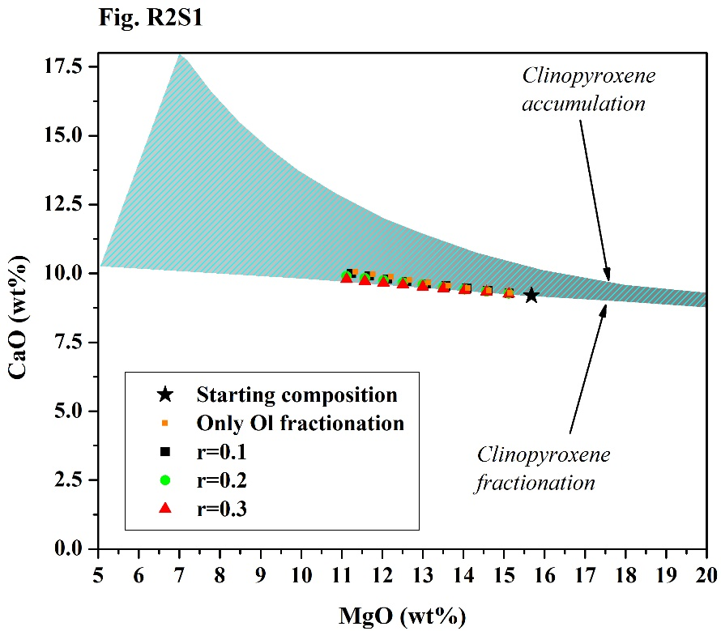

Repository Fig. R2S1. Change in MgO vs. CaO values due to Olivine fractionation and subsequent assimilation at different “r” values, where “r” represents relative ratio of assimilated material to crystallized material. The starting composition indicates the experimental melt composition from Davis and Hirschmann (2013).
The example illustrates that T_{p} values can be influenced when a substantial amount of crustal assimilation occurs. Negligible amount of crustal assimilation at lower olivine fractionation results in minimal change in T_{p} values.

References
Davis FA, Hirschmann MM (2013) The effects of K 2 O on the compositions of near-solidus melts of garnet peridotite at 3 GPa and the origin of basalts from enriched mantle. Contributions to Mineralogy and Petrology 166:1029–1046
Ersoy Y, Helvaci C (2010) FC–AFC–FCA and mixing modeler: a Microsoft® Excel© spreadsheet program for modeling geochemical differentiation of magma by crystal fractionation, crustal assimilation and mixing. 36:383–390
Rudnick RL, Gao S, Holland HD, Turekian KK (2003) Composition of the continental crust. The crust 3:1–64

