- Effects of Neglecting Clinopyroxene or Plagioclase fractionation
The thermobarometric formulations in Lee et al. (2009) require knowledge regarding the primary magma composition, i.e., the composition of the magma when it was last in equilibrium with the mantle to calculate the average magma generation pressure (P_{g}) and temperature (T_{g}). As erupted magmas undergo some degree of mineral fractionation at crustal level, the primary magma composition has been inferred by reversing the fractionation process (Lee et al. 2009). Sometimes, the evolved magma is saturated with clinopyroxene and plagioclase along with olivine, and reversing the fractional crystallization of such magma is much difficult. This is because the exact proportion of each fractionating mineral is not known. To estimate the percentage of fractionation, the entire differentiation suite is necessary. To avoid this problem, Lee et al chose the most primitive magmas, similar to few previous workers (Putirka 2005; Herzberg et al. 2007; Herzberg and Asimow 2008, 2015), that have undergone olivine fractionation only. By negating plagioclase fractionation, the SiO₂ and MgO are overestimated. This results in somewhat higher T and P. Similarly, overlooking clinopyroxene fractionation underestimates SiO₂ and overestimates MgO, resulting in lower P and higher T.
- Anhydrous source of origin for T_{p} calculation
Lee et al’s thermobarometry can be applied for both hydrous and anhydrous magma. However, their formulations are calibrated to a minimum water content of 2 wt%, and considering lower water content than that suppresses the pressure estimation. Such high-water content magmas are characteristics of arc environment, where basalts generate through partial melting of a wet peridotite source. On the other hand, the ambient mantle derived basalts are originated from decompression melting of a dry peridotite source. Studies show that ambient mantle derived basalts (MORBs) contain a maximum up to 0.5 wt% of H₂O (Michael 1995; Sobolev and Chaussidon 1996; Danyushevsky 2001), and are dry magmas in nature. The T_{p} calculations from this study is based upon the ambient mantle derived basalts from Archean to Proterozoic. As discussed earlier, basalts derived from the ambient mantle are considered to be dry in nature. Therefore, all our calculations are conducted by assuming an anhydrous source of origin. Previous studies have also adopted a similar approach, considering an anhydrous source, to calculate the T_{p} of the ambient mantle (Komiya et al. 2002; Putirka 2005; Herzberg et al. 2010; Ganne and Feng 2017; Aulbach and Arndt 2019).
- Assumptions regarding the final Mg# of olivine
To calculate P_{g}, and T_{g}, for input basalt, Lee et al. (2009) applied a polybaric decompression melting process. Polybaric decompression melting initiated by solid-state upwelling, promotes melting along a path of changing pressure and temperature. The calculated primary melt composition in this process represents the weighted average aggregate melt composition. Lee et al. (2009) used a polybaric batch melting model to calculate the primary magma composition of a primitive basalt that has experienced only olivine fractionation. Batch melting refers to a process where the partial melt remains in equilibrium with its mantle residue at various melt fractions. Consequently, the authors have taken into account an average value of olivine Mg# to represent the mantle residuum. They first estimated an equilibrium olivine composition to the input basalt and added the olivine back into the magma until the magma equilibrates with olivine having an Mg# equivalent to the average mantle residuum. Varying the residuum Mg# to 1 unit can increase or decrease the temperature upto 50-100℃.
We acknowledge that considering a final forsterite content might cause some uncertainties to our calculation. For example, the approach over-estimates temperatures if melting degrees are lower and under-estimates if melting degrees are higher. To reduce the inconsistency in assuming the final forsterite content, Herzberg and co-workers (Herzberg et al. 2007; Herzberg and Asimow 2008, 2015) simultaneously calculated the T_{p} and olivine Mg#. In other words, their approach is self-consistent and does not need a final olivine forsterite number to be fixed to calculate the T_{p}.
Note that the physical meaning of olivine Mg# in Herzberg’s and Lee’s methods differ. While the iteratively calculated olivine Mg# in Herzberg’s method represents the Mg# of olivine to be crystallized from primary magma at 1 atmospheric pressure, the olivine Mg# required as input in Lee’s method represents the Mg# of residual mantle source. This is because Herzberg’s methodology to calculate primary magma composition is based on fractional melting equations, where the accumulated fractional melt is never in equilibrium with its residue except the final drop of liquid. Previous studies have shown that primary magmas produced by fractional melting have slightly higher FeO and lower SiO₂ content than batch melts at constant MgO content (Langmuir et al. 1992; Herzberg 2004). Later, Asimow and Longhi (2004) showed that primary melts, produced via accumulated fractional melting of fertile upper mantle peridotites can be very similar to that of batch melts in terms of MgO and FeO content.
Polybaric melting, resulting from the adiabatic decompression melting of mantle would leave a residue where the degree of depletion decreases with depth. This is apparent from the xenolithic evidence for polybaric melt extracts (Xu et al. 2002), where the Mg# of residual olivine show a negative relation with depth. As the calculated primary melt composition represents weighted average aggregate melt composition produced via polybaric decompression, the residual olivine composition in the mantle must also represent an average Mg# value, produced during this process. In this context we have utilized a mean value of residual olivine Mg# derived from the polybaric fractional melting, using the parameterization of Herzberg (2004) and Herzberg and Rudnick (2012). For a hot-ridge melting during the Archean, the mean value of residual olivine Mg# is 0.92, whereas this value can be 2 units higher during a hot plume melting event during the Archean (fig. 5 in main text). During Proterozoic to Phanerozoic the Olivine Mg# decreases from 0.912 to 0.908 for ridge melting (Herzberg 2004; Herzberg and Rudnick 2012).
The Archean mantle xenoliths from cratonic lithosphere show an average Olivine Mg# (Fo) of 0.92 (Servali and Korenaga 2018), supporting the recent idea that depleted peridotites from the Archean cratonic lithospheric mantle are the residual product of basaltic primary melt extraction in a typical hot mid-ocean ridge (MOR) setting, rather than in a plume setting (Rollinson 2010; Herzberg and Rudnick 2012; Pearson and Wittig 2014; Herzberg 2018; Servali and Korenaga 2018). These peridotites later became part of the continental lithospheric mantle through processes such as orogenesis or underthrusting events. The basaltic crust was subsequently recycled to the mantle due to density inversion during subduction. Few of these Archean MOR basalts are preserved as non-arc basalts in Archean Greenstone belts. If this holds true, then using an average residuum olivine Mg# of 0.92 to calculate T_{p} for our study should align with previous T_{p} estimations for ambient mantle, based on both petrological and modeled values. Table R1T1 presents a comparison of mantle potential temperature (T_{p}) values for Archean basalts originally employed by Herzberg et al. (2010). The Tp values were re-calculated using their updated PRIMELT3 (Herzberg and Asimow 2015) algorithm and, concurrently, determined through the FRACTIONATE-PT software, incorporating an olivine Mg# of 0.92. Additionally, in both cases, the Fe⁺²/Fe ^{total} ratio was maintained at a constant value of 0.9.

Table R1T1: Comparison between the Tp values for Archean basalts from PRIMELT3 and FRACTIONATE-PT
Sample No | Location | Age (Ma) | Tp (℃) from PRIMELT3 | Tp (℃) by considering residuum Ol Mg# = 0.92 (FRACTIONATE-PT) | ∆T_{p} (T_{p} ^{PRIMELT3} - T_{p} ^{FRACTIONATE-PT}) (unitless)
gc010697 | Coonterunah Gp, Pilbara | 3520 | 1448.916963 | 1455.66282 | -6.74585763
02MB256 | Warrawoona | 3450 | 1536.99506 | 1566.212117 | -29.21705694
M-14-16 | Minnesota, U.S.A. | 3255 | 1624.858428 | 1641.846865 | -16.98843743
96048540D | Sulfur Sprgs Gp, Pilbara | 3246 | 1626.892503 | NA | NA
485418 | Ivisaartoq 1, Greenland | 3075 | 1549.062115 | 1575.90257 | -26.8404557
485420 | Ivisaartoq 1, Greenland | 3075 | 1514.470098 | 1491.262457 | 23.20764123
I-417 | Iringora 'ophiolite' Finland | 2800 | 1587.219972 | NA | NA
I-417/2 | Iringora 'ophiolite' Finland | 2800 | 1602.476172 | NA | NA
RKY-17 | Kushtagi-Hungund, India | 2746 | 1612.46851 | 1560.290334 | 52.17817645
RKY-18 | Kushtagi-Hungund, India | 2746 | 1523.325625 | 1535.92639 | -12.6007648
s MU96-20 | Superior, Canada | 2700 | 1488.887087 | 1496.591921 | -7.704833696
s DH95-3 | Superior, Canada | 2700 | 1550.861812 | 1557.537682 | -6.675869591
s T-7 | Superior, Canada | 2700 | 1545.850084 | 1553.893266 | -8.043182132
2 | Aravalli Supergroup, India | 2550 | 1653.687403 | 1648.235736 | 5.451666394

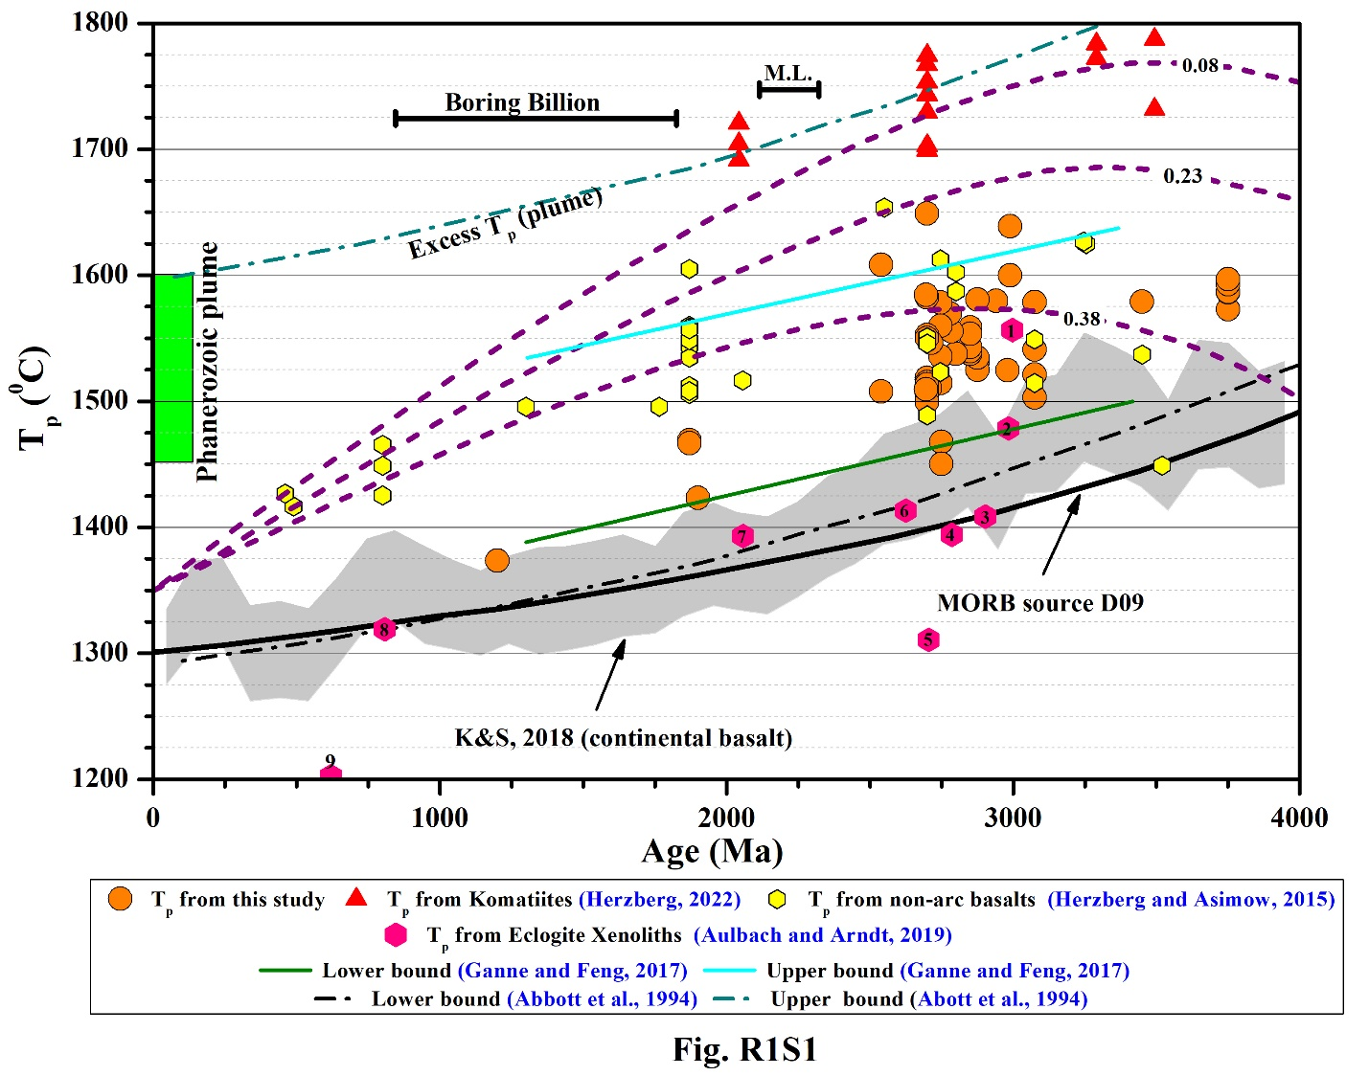
Repository Fig R1S1. Mantle potential temperature (T_{p}) variation with age calculated from the magma generation temperature (T_{g}) and pressure (P_{g}) from Lee et al. (2009), utilizing an average olivine Mg# of 0.92 for Archean and 0.912 for Proterozoic samples. The redox condition is considered as Fe⁺³/Fe _{Total} = 0.1. Three values of Urey ratio (0.23, 0.38, 0.08) (Korenaga 2008) are shown. As a function of age, also shown are the T_{P} based on liquidus temperatures of suggested MORB-like mafic suites (Abbott et al. 1994), MORB source mantle from (D09) (Davies 2009) based on parameterised convection models with conventional heat-flow scaling, mantle T_{p} from Herzberg and Asimow (Herzberg and Asimow 2015) from Archean and Proterozoic DM, and EM derived basalts, T_{p} minima and maxima from Ganne and Feng (2017) calculated from non-arc basalts, T_{P} range for a pressure of 2.2 to 3.2 GPa based on the chemical composition of continental basalts e.g., condition in the arc mantle wedge from Keller and Schoene (2018). Mantle potential temperature observed from mantle eclogite xenoliths (Aulbach and Arndt 2019) are shown in olive green hexagons. 1: Siberian Craton, 2: Kaapvaal Craton, 3: Karelia Province, 4: North-Atlantic craton, 5: Superior Craton, 6: Dharwar Craton 7: Flin Flon 8: Zambia 9: Balkan-Carpat. For comparison, Tp values from Komatiites and Phanerozoic Plume are shown (Herzberg 2022). M.L.: Magmatic Lull from 2300 Ma to 2200 Ma (Spencer et al. 2018). Boring Billion from 1800Ma to 800Ma (Roberts 2013).

References
Abbott D, Burgess L, Longhi J, Smith WHF (1994) An empirical thermal history of the Earth’s upper mantle. J Geophys Res Solid Earth 99:13835–13850
Asimow PD, Longhi J (2004) The significance of multiple saturation points in the context of polybaric near-fractional melting. Journal of Petrology 45:2349–2367
Aulbach S, Arndt NT (2019) Eclogites as palaeodynamic archives: Evidence for warm (not hot) and depleted (but heterogeneous) Archaean ambient mantle. Earth Planet Sci Lett 505:162–172. https://doi.org/10.1016/j.epsl.2018.10.025
Danyushevsky L V (2001) The effect of small amounts of H2O on crystallisation of mid-ocean ridge and backarc basin magmas. Journal of Volcanology and Geothermal Research 110:265–280
Davies GF (2009) Effect of plate bending on the Urey ratio and the thermal evolution of the mantle. Earth Planet Sci Lett 287:513–518. https://doi.org/10.1016/j.epsl.2009.08.038
Ganne J, Feng X (2017) Primary magmas and mantle temperatures through time. Geochemistry, Geophysics, Geosystems 18:872–888. https://doi.org/10.1002/2016GC006787.Received
Herzberg C (2004) Geodynamic information in peridotite petrology. Journal of Petrology 45:2507–2530. https://doi.org/10.1093/petrology/egh039
Herzberg C (2018) From hot oceanic ridges to cool cratons. Geology 46:1079–1080
Herzberg C (2022) Understanding the Paleoproterozoic Circum-Superior Large Igneous Province constrains the thermal properties of Earth’s mantle through time. Precambrian Res 375:. https://doi.org/10.1016/j.precamres.2022.106671
Herzberg C, Asimow PD (2015) PRIMELT3 MEGA.XLSM software for primary magma calculation: Peridotite primary magma MgO contents from the liquidus to the solidus. Geochemistry, Geophysics, Geosystems 16:563–578. https://doi.org/10.1002/2014GC005631.
Herzberg C, Asimow PD (2008) Petrology of some oceanic island basalts: PRIMELT2.XLS software for primary magma calculation. Geochemistry, Geophysics, Geosystems 9:. https://doi.org/10.1029/2008GC002057
Herzberg C, Asimow PD, Arndt N, et al (2007) Temperatures in ambient mantle and plumes: Constraints from basalts, picrites, and komatiites. Geochemistry, Geophysics, Geosystems 8:. https://doi.org/10.1029/2006GC001390
Herzberg C, Condie K, Korenaga J (2010) Thermal history of the Earth and its petrological expression. Earth Planet Sci Lett 292:79–88. https://doi.org/10.1016/j.epsl.2010.01.022
Herzberg C, Rudnick R (2012) Formation of cratonic lithosphere: An integrated thermal and petrological model. Lithos 149:4–15. https://doi.org/10.1016/j.lithos.2012.01.010
Keller B, Schoene B (2018) Plate tectonics and continental basaltic geochemistry throughout Earth history. Earth Planet Sci Lett 481:290–304
Komiya T, Maruyama S, Hirata T, Yurimoto H (2002) Petrology and Geochemistry of MORB and OIB in the Mid-Archean North Pole Region, Pilbara Craton, Western Australia: Implications for the Composition and Temperature of the Upper Mantle at 3.5 Ga. Int Geol Rev 44:988–1016. https://doi.org/10.2747/0020-6814.44.11.988
Korenaga J (2008) Urey ratio and the structure and evolution of Earth’s mantle. Reviews of Geophysics 46:1–32. https://doi.org/10.1029/2007RG000241
Langmuir CH, Klein EM, Plank T (1992) Petrological systematics of mid‐ocean ridge basalts: Constraints on melt generation beneath ocean ridges. Mantle flow and melt generation at mid‐ocean ridges 71:183–280
Lee C-TA, Luffi P, Plank T, et al (2009) Constraints on the depths and temperatures of basaltic magma generation on Earth and other terrestrial planets using new thermobarometers for mafic magmas. Earth Planet Sci Lett 279:20–33
Michael P (1995) Regionally distinctive sources of depleted MORB: Evidence from trace elements and H2O. Earth Planet Sci Lett 131:301–320
Pearson DG, Wittig N (2014) The formation and evolution of cratonic mantle lithosphere–evidence from mantle xenoliths
Putirka KD (2005) Mantle potential temperatures at Hawaii, Iceland, and the mid‐ocean ridge system, as inferred from olivine phenocrysts: Evidence for thermally driven mantle plumes. Geochemistry, Geophysics, Geosystems 6:
Roberts NMW (2013) The boring billion?–Lid tectonics, continental growth and environmental change associated with the Columbia supercontinent. Geoscience Frontiers 4:681–691
Rollinson H (2010) Coupled evolution of Archean continental crust and subcontinental lithospheric mantle. Geology 38:1083–1086
Servali A, Korenaga J (2018) Oceanic origin of continental mantle lithosphere. Geology 46:1047–1050
Sobolev A V, Chaussidon M (1996) H2O concentrations in primary melts from supra-subduction zones and mid-ocean ridges: implications for H2O storage and recycling in the mantle. Earth Planet Sci Lett 137:45–55
Spencer CJ, Murphy JB, Kirkland CL, et al (2018) A Palaeoproterozoic tectono-magmatic lull as a potential trigger for the supercontinent cycle. Nat Geosci 11:97–101. https://doi.org/10.1038/s41561-017-0051-y
Xu YG, Sun M, Yan W, et al (2002) Xenolith evidence for polybaric melting and stratification of the upper mantle beneath South China. J Asian Earth Sci 20:937–954

